SM Wheelchair flutter application

Wireless & Mobile Computing Project

Faculty of computers and information

Wireless & Mobile Computing

 

**Wireless & Mobile Computing Project**

**Information Technology Department**

**Faculty of computers and information**

**Luxor University**

Submitted by:

|  |
| --- |
| Khaled Ahmed |
| Ahmed Mohamed Hassan |
| Haidy Hendy Danial Tawadros |
| Fatma Younes |
| Rehab Rabea Saeed |
| Hafsa Desoukey |

**Supervised By:**

**Dr. Hosny Ahmed Abbas**

**&**

**Dr. Ibrahim El-Sayed**

**Abstract**

E-commerce platform activities are a subset of e-business activities, and they have recently become significant in several industries.

The purpose of this paper is to construct and develop a trustworthy flutter application based on e-commerce theories, creating efficient, attractive mobile pages.

This flutter application will sell things for computers, such as (hardware and software).

Use of modern technologies is required to develop the online store in order to do this.

A simple-to-use online store should be set up as the initial step.

Finally, execute the Direct Online Sale between Business and Consumer by implementing electronic payment methods.

First, enhance the customer experience.

All of these strategies should be based on an intentional plan that follows the electronic commerce strategy and uses the most recent technology.

**Introduction**

**How to help people with special needs:**

A disabled person is any person who has a physical or mental disability that significantly limits at least one life activity. There is a lot you can learn if you want to help people with special needs. Learning to communicate effectively with them is the first step and you can offer your services as a volunteer.

**Develop communication skills:**

Know the appropriate terminology. Make sure you use the right words when discussing people with special needs. Some words were considered normal in the past but now may be considered offensive. The first step in helping people with special needs is to know the right words. When speaking about a person with a disability, it is best and most polite to put their personality before their special condition. Example: Don't say "mentally ill person" or "mentally ill person". Better to say "a person with a mental disability". Don't say "paralyzed," but talk about it another way as you would a person. If you want to talk specifically about a wheelchair, say "a person in a wheelchair." Keep in mind that there are some exceptions worth noting here. Many people who are blind, deaf, or autistic prefer to be identified as autistic or "deaf" to indicate that they are part of that community.

Certain words may be correct in meaning but are considered offensive. Words like "dumb" or "dumb" may have been correct in describing someone who cannot speak, but now words like "apathetic" or "unable to speak" are better words. The terms crippled or paralyzed are correct in describing a person who has a disability that limits his movement and makes him unable to walk, but now there are better terms such as physically disabled or disabled.

The terms "retard" and "mentally ill" are considered derogatory these days. It is better to describe him as a person with a mental, developmental or intellectual disability. Deranged, retarded, or insane are correct words, but many use them to demean a person, so it is better to avoid them so that the person you speak to does not feel offended.

**The purpose of the project:**

This project has been designed for people with special needs and people with disabilities in all their categories and providing some tools they use in their lives to make their lives easier in dealings.

This program will keep pace with the digital transformation that the state seeks to become a digital state in all transactions and every person can choose the prices that are suitable for products and provide the time required to buy

**Tools used in this project:**

Flutter to execute this mobile application.

**Description:**

**Analysis Phase:**

**Use case diagram:**

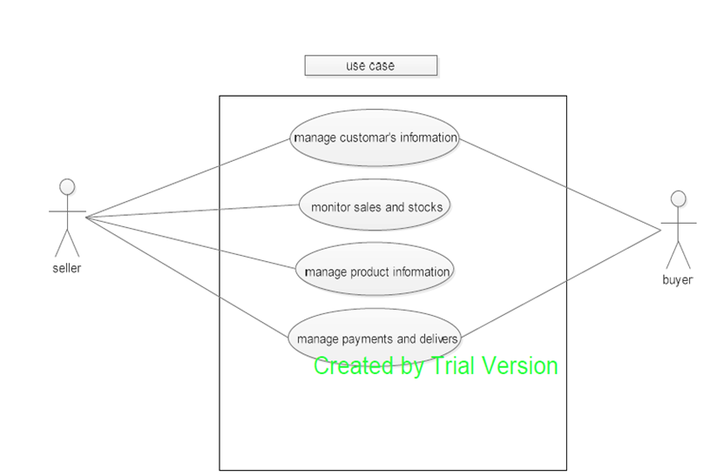

**Class Diagram:**

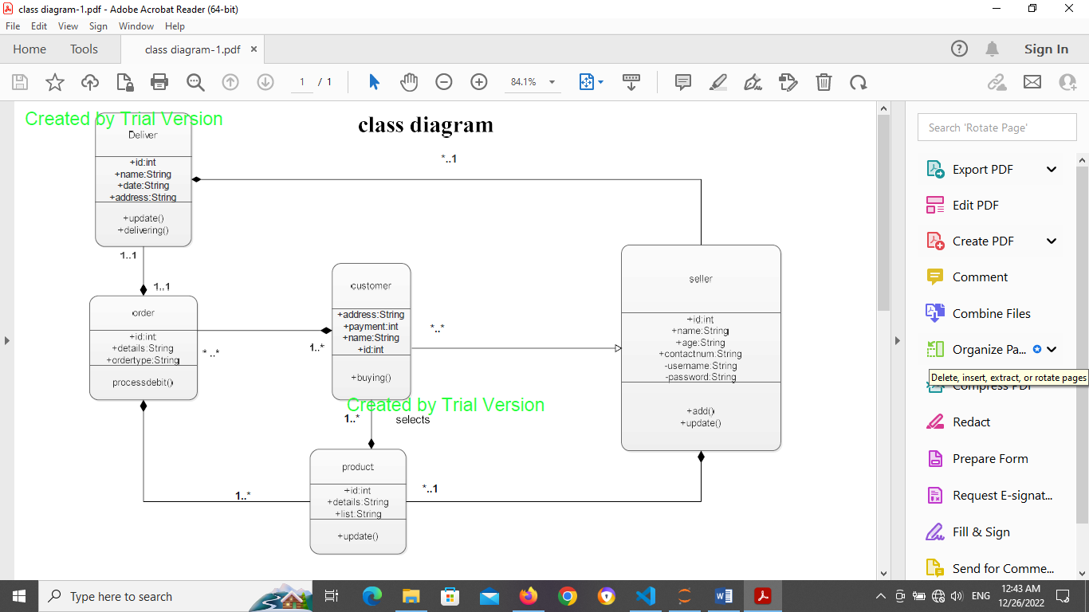

**Sequence Diagram:**

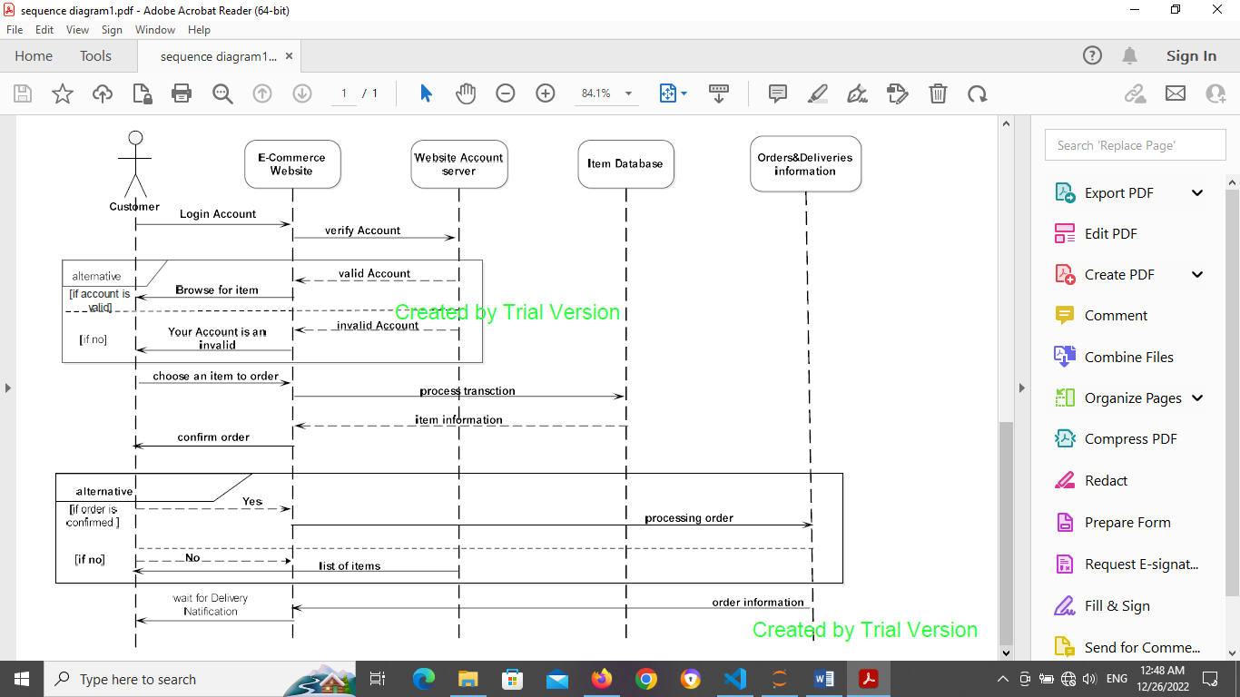

**Activity diagram:**

